**QUESTION 1: MODULE TESTS**

***1.1. Coding Basics***

Module 1: 100

Module 2: 100

Module 3: 100

Module 4: 100

***1.2. Intermediate***

Module 1: 100

Module 2: 100

Module 3: 100

Module 4:

***1.3. Calculation***

Sum:

Total (rounded up): # marks

**QUESTION 2: FINAL TEST**

***2.1. Result and Calculation***

Result:

Sum:

Total (rounded up): # marks

**QUESTION 3: PRACTICAL ACTIVITY**

***3.1. Important Note***

Word-wrap disrupts the code display below; see the readable (plain text) file accompanying this document in the submitted zip file.

***3.2. Program Copied and Pasted***

class Encryption:

"""

This class provides a Caesar based cipher generator.

"""

def __init__(self):

""""

Initialises the class with a default shift value of 0; required for graceful exit on KeyboardInterrupt.

"""

self.__shift_value = 0

def get_user_input(self):

""""

This method asks the user for the word or text to be encrypted, and for their birth month which acts as a key.

Input validation is performed; and, provides option to exit gracefully without mandatory input.

"""

self.__word = input("Please enter word(s) or text to be encrypted: ")

while True: # Loop continues until input is valid or user exits gracefully.

try:

bday_m = int(input("Please enter your birth month (01 to 12): "))

if bday_m >= 1 and bday_m <= 12: # Validate input 'before' updating self.__shift_value to guard against invalid or unwanted encryption on KeyboardInterrupt.

self.__shift_value = bday_m

break

except KeyboardInterrupt: # Enables user to exit without mandatory input.

print("Program ended gracefully: Word was not encrypted:")

break

except:

print("Invalid Input - Please only enter a valid birthday month (1 to 12):") # Repeats until valid, or KeyboardInterrupt.

def encrypt(self):

"""

Encrypts the user's word/text based on the Caesar algorithm and returns the cipher.

Non-alphabetical characters are simply copied to the new cipher string, preserving original position.

Modulus based formula allows wrapping back around to 'A' after 'Z'.

"""

cipher = '' # Initialise cipher string.

ascii_uppercase_start = ord('A') # ASCII start for uppercase, used in Modulus formula below.

ascii_lowercase_start = ord('a') # '' '' lowercase '' ''

for c in self.__word: # Loop through user's word or text.

ascii_letter = ord(c) # Get current character's ASCII code.

if c.isalpha() == False: # If a character in the user's word/text is not a letter, do not encrypt it; only copy it:

cipher += c

elif c.isupper():

cipher += chr((ascii_letter + self.__shift_value - ascii_uppercase_start) % 26 + ascii_uppercase_start) # After Z, formula allows wrapping back around to A.

elif c.islower():

cipher += chr((ascii_letter + self.__shift_value - ascii_lowercase_start) % 26 + ascii_lowercase_start) # '' ''

return cipher

cipher_generator = Encryption() # Create encryption object

cipher_generator.get_user_input() # Get cipher's user defined paramaters

print("Cipher:", cipher_generator.encrypt()) # Print encrypted output.

***3.3. Program Testing***

Screen-shots providing evidence the program runs flawlessly with complete input validation and exception handling.

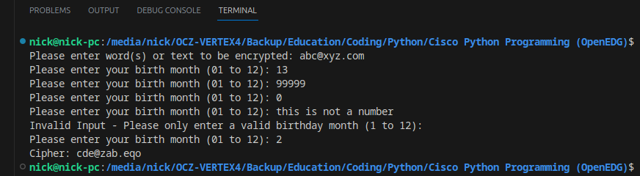Figure 1: Screen-shot 1

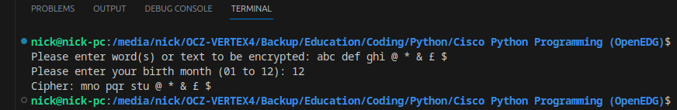Figure 2: Screen-shot 2

**QUESTION 4: ACADEMIC ESSAY**

***4.1. Introduction***

This essay dissects the author’s work on a cipher generator, covering command selection, design methodology, and alignment with current professional practices.

***4.2. Commands and Functionality***

Upon instantiation, the get_user_input() method is called, prompting the user for word(s) or text and a shift value (key). Input validation is executed through a try-except block inside an infinite while loop, which only breaks upon valid input between 1 and 12. The program permits graceful exit via KeyboardInterrupt. The encrypt() method is executed when the print function is called.

First, ASCII codes for the alphabets are retrieved using the ord() function. A for-loop then traverses the user's text, collecting each character's ASCII code. An if-elif construct processes each character one at a time. Non-alphabetic characters are directly appended to the cipher string, while alphabetic characters are shifted via the Caesar algorithm.

The modulus operator '%' is crucial for the algorithm, enabling the alphabet to loop from 'Z' back to 'A'. This technique employs modular arithmetic, often overlooked in traditional mathematics but indispensable in computer science (Ringenberg, 2021). The modulus ensures that the remainder will not surpass the alphabet's length of 26. This concept aligns with how 12-hour clocks are understood in early childhood: 9 + 4 equals 1, not 13. Using a modulus of 12 clarifies this, as 13 % 12 equals 1 (Ringenberg, 2021). Mathematically, the Caesar encryption can be defined by the formula: 'E_k(x) = (x + k) mod 26' (Padhye et al., 2018).

***4.3. Design Approach***

The design paradigm chosen was Object-Oriented Programming (OOP), with all functionality being encapsulated in the Encryption class. This modular approach makes the program more easily debugged, maintained, and expanded. For example, we could safely add a new method to decrypt the cipher with a known key, or to battle-test it with brute force. Exception handling for input validation with immediate descriptive feedback (and graceful exit option) improves the user experience. Private variables were chosen for the unencrypted word and the key.

***4.4. Professional Practice Adherence***

“Truly” private variables that can’t be accessed do not exist in Python, but following this as a convention is still preferred practice (Python Software Foundation, 2023). Name mangling is more secure than nothing, as it helps avoid accidents, which aligns with the principle of least privilege, enhancing code security. A positive user experience during program interaction conveys professionalism. The code is also well-commented, with all classes and methods initially introduced with a doc string; further, all important lines are individually commented. Methods like get_user_input() and encrypt() are compartmentalised for easier debugging Lastly, the many different operands requiring ASCII conversion are stored as constants before being used in the modulus formula, making it more intuitive.

Word Count *(question 4)*: 508

***References***

Padhye, S., Sahu, R.A. and Saraswat, V. (2018) *Introduction to Cryptography.* 1st edn. Milton: CRC Press. Available at: <https://doi.org/10.1201/9781315114590>.

Python Software Foundation (2023) *9.6 Private Variables*. Available at: [https://docs.python.org/3/tutorial/classes.html#private-variables](https://docs.python.org/3/tutorial/classes.html" \l "private-variables) (Accessed: 7 September 2023).

Ringenberg, J. (2021) *An Investigation of Students’ Understanding of the Modulo Operator.* Master Thesis. University of Nebraska at Omaha. Available at: <https://unomaha.primo.exlibrisgroup.com/permalink/01UON_OMA/1tllovp/cdi_proquest_journals_2584353635> (Accessed: 7 September 2023).